**Drexel University**

**College of Computing & Informatics**

**SE 627**

**Requirements Engineering and Management**

**Stakeholder Requirements Specification**

**Credit Reporting System**

**By**

Shreekant Malviya

Yiyun Zhang

Raphael Perez

Andrew Dougherty

**Contents**

**1. Introduction** **2**

1.1 Business Purpose 2

1.2 Business Scope 3

1.3 Business Overview 3

1.4 Definitions 3

1.5 Stakeholders 3

**2. References** **5**

**3. Business Management Requirements** **6**

3.1 Business Environment 6

3.2 Goal and Objective 6

3.3 Business Model 6

3.4 Information Environment 7

**4. Business Operational Requirements** **7**

4.1 Business Processes 7

4.2 Business Operational Policies 8

4.3 Business Operational Constraints 8

4.4 Business Operational Modes 9

4.5 Business Operational Quality 9

4.6 Business Structure 9

**5. User Requirements** **10**

**6. Concept of Proposed System** **10**

**7. Project Constraints** **10**

**A. Acronyms and Abbreviations** **10**

## 

## **1. Introduction**

### **1.1 Business Purpose**

The Credit Reporting system will perform customer credit management and report generation for consumers and creditors. The Credit Reporting system will accept credit data from users, generate reports, and implement security measures. The system is proposed to make consumer credit reporting more convenient to consumers/lenders. This consumer credit reporting system will make the credit reports available instantly on requests and permits quick decision making at the retailers, auto-showrooms, and real estate. The system would be a great help to consumers who wait for months to get their credit history.

### **1.2 Business Scope**

The Credit Reporting system will perform customer credit management and report generation for consumers and creditors. The system will accept credit data transmission from all authorized business partners. The transmission process can be any time, there is no time window limit except the monthly maintenance. There is JSON format data but no size limitation for the customer data. The system will report accurate and consistent data. The system has a secure consumer database management system and has sufficient storage to store all the upcoming data without being exposed to data breaches. The online system will have a customer care center if the consumers have any issues they can contact here.

### **1.3 Business Overview**

The Credit Reporting System consists of customer credit management, Customer public data management, and system & security management. The credit management system is responsible for the collection, management, and distribution of the customer credit reports and lender’s information. Customer public data management takes care of all the information associated with the consumer’s public records and bankruptcy. System & security management system is responsible for the timely maintenance of the system and makes sure that all the incoming and outgoing is secure and not susceptible to data breaches.

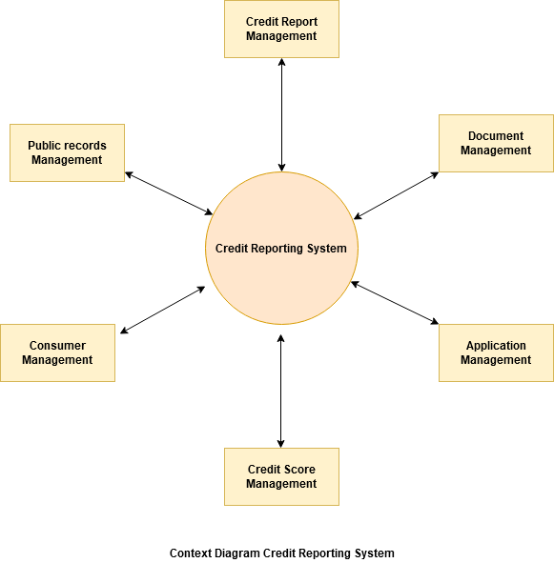

### **1.4 Definitions**

There are no definitions in the document.

### **1.5 Stakeholders**

The List of stakeholders involved in the system are:

1. **Consumer:**

Consumers are a key part of the system, their credit and loan accounts are reported to the bureau.

1. **Creditor:**

Creditors are the ones who request data from the bureaus about consumers when deciding what rates to offer to consumers based on their credit reports.

* Lenders (including those that offer credit cards, home, payday, personal, title, auto including auto leasing, student loans, and security deposit financing and lease guarantee on home rentals)
* Employers, volunteer organizations, and government agencies to determine eligibility for government assistance (employment screening)
* Landlords and residential real estate management companies (tenant screening)
* Banks, credit unions, payment processors, and retail stores that accept personal checks (check screening)
* Companies that market and sell products and services specifically to lower-income consumers and subprime credit applicants, such as short-term lending and rent-to-own businesses among others
* Insurance companies (health, life, property insurance screening)
* Communications and utility companies (e.g., mobile phone, pay TV, electric, gas, water)
* Retail stores for product return fraud and abuse screening as well as retail stores that offer financing such as appliance and rent-to-own businesses, among other gaming casinos that extend credit to consumers and/or accept personal check

1. **Credit Bureau:**

Credit Bureaus are responsible for collecting records and distributing information about the credit habits of the consumer.

* Information about consumer payment history as submitted by credit card companies, home and auto lenders (and leasing companies), and other creditors.
* How much credit consumers have and use.
* Information from debt collectors including unpaid medical debt that is greater than 180days delinquent from date of service, and past-due debt from cable and phone bills.
* Some public information like bankruptcies.
* Inquiries from creditors who have requested consumer credit reports when consumers apply for credit.

1. **Maintenance Personnel:**

Maintenance personnel keep track of the Credit reporting system and activities. They are responsible for editing, updating, and maintaining the system and make sure that the system is available 95.99% times.

1. **Data Manager:**

Data managers are responsible for managing, storage, all the incoming and outgoing data and reporting real-time data of the users of the system, and make sure the data is consistent, accurate, and free from functional dependencies.

1. **Security Manager:**

Security Managers are responsible for the security of the credit reporting system and make sure that the system is not susceptible to data breaches.

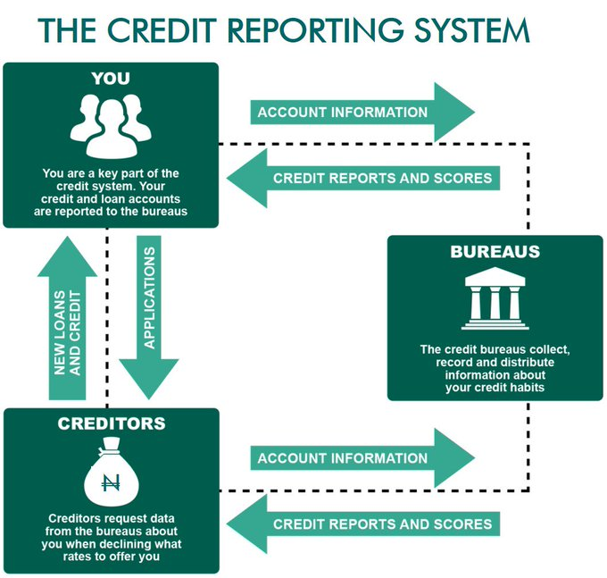

***Information flow of Credit Reporting System.***

## **2. References**

1. *Systems and methods for providing a customizable credit report. Patricia Cheryl Lassen, Karthikeyan Reddy, Aaravabhoomi. Date: Dec 03, 2012*
2. *Personal credit management and monitoring system and method. John Owen, Emily Deere, James Weinberg. Date: Dec 20, 2004*
3. *Method to electronically track personal credit information. Brian Siegel. Date: June 7, 2000*
4. *Operational Concept Document Credit Reporting System.*

## **3. Business Management Requirements**

### **3.1 Business Environment**

The current business environment has few external and internal factors that influence the implementation of this system. Internal factors, such as market trends, do not have a significant impact on whether a potential candidate for a loan will be able to meet the loan requirements. External factors, such as a candidate increasing their debt to income ratio, would have a significant impact on the candidate’s ability to meet the loan requirements. With the current credit reporting system, a candidate’s ability to meet loan requirements can be delayed up to 90 days. Furthermore, it could take up to a month to see if a candidate opened a new line of credit while attempting to open more creating more risk for the loan writer.

### **3.2 Goal and Objective**

The goal of the new Credit Reporting System is to update a person’s credit report in near real-time, within one day. This would help eliminate the potential risk for investors and loan writers and help candidates who are in good standing achieve the funds they need.

### **3.3 Business Model**

The Credit Report Software will perform customer credit management and report generation for clients and users. The proposed system will use a user’s electronic bank and credit transaction history to update its credit in real-time. If a pending transaction is reversed the Credit Report Software will be able to reverse any false updates in real-time as well. This proposed business model will fix the problems the current system is experiencing in order to meet the business goals. The current system issues include: update once a month, cannot be accessed by external internet due to security concern, and unable to erase invalid information in the database. The new system will update customer data once a day, accessible through external internet and capable of eliminating out-of-date credit data

|  |  |  |  |  |
| --- | --- | --- | --- | --- |
| **Key partners**   * Credit Bureau. * IT Solution provider * Local Banks * Consumers | **Key activities**   * Platform (database, UI development) * customer data acquisition, content creation and report creation) | **Value Propositions**   * Links customers with existing local vendors, creditors, and bank * Instant Credit Report delivery * No membership fees * No Digital payment * Increase number of consumer credit records * Enhanced Security * Consistent Data * Real Time Credit Reporting | **Customer Relationship**   * 24/7 customer support * Phone calls * Chat box * Social media * Website and application interactions | **Customer Segment**  **Users**   * People who seek loans, Mortgage. * People who sign lease for home, want to buy a car, home etc. * People with busy schedule, who cannot physically apply for the reports * Hiring Employers     **Banks**   * Banks who provide loans and credits. * Banks that wants to increase their Business |
| **Key Resource**   * Partnership with local banks, creditors and vendors * Web and mobile application development. * Customer database. | **Channels**     * Website * Mobile App for iOS * Mobile App for Android |

### **3.4 Information Environment**

*Project Portfolio:*

When multiple projects, such as upgrades or new software versions need to be implemented, are being worked on we will prioritize keeping the Credit Reporting Software functional and as quick as possible. When events arise such as maintenance or other ‘blackouts’ where service is down, we will focus on restoring the end-user functionality to keep users and clients happy. This may impact the quality of the project but we feel it is important to keep the service functional at all times to ensure accurate results.

*Long Term System Plan:*

The long term system plan for Credit Reporting Software is to have hardware and software support available from the initial launch of the software through the retirement of the software. During the life of the software, the business will need to evaluate the potential flaws in the system and attempt to engineer a solution for the software’s successor. The business will also need to be able to adjust for any major software changes that will need to be implemented that could potentially affect the business and reporting software. This may cause design constraints as the business will need to make adjustments to the software to give the user and client the best experience.

*Database Configuration:*

The database configuration of the Credit Reporting Software will need to be able to be accessed in real-time to keep the information as accurate as possible. It will also need to be able to perform automatic and manual backups to ensure data recovery is possible in the event of database corruption. Furthermore, the database will only not be accessible during scheduled maintenance or downtime. Finally, the system will need a server large enough to host this database to ensure data integrity and system availability during disaster events.

## **4. Business Operational Requirements**

### 4.1 Business Processes

1. *Administration*
   1. This process handles business needs such as Human Resource requirements and various duties for the business need
2. *Operations*
   1. This process handles the day to day operation standards for the software and business. It also includes everything required to accept an order or request, deliver the service, and send an invoice to the customer
3. *Procurement*
   1. Procurement processes include the steps required to acquire parts and materials needed for the business to provide the service. Procurement will also encompass purchasing, accounts payable, and receiving.
4. *Information Technology and Security*
   1. This process performs security audits to look for vulnerabilities in the software to ensure the software is as secure as promised to the customer. Also, this process will provide the appropriate permissions to employees, clients, and end-users to establish a user hierarchy and secure data.
5. *Customer Service*
   1. This process will investigate and attempt to resolve all customer complaints. The process will also provide valuable feedback to the business’ change management process
6. *Change Management*
   1. This process continuously looks for ways to keep the business and software ahead of or at the “business standard”. This means they are looking for ways to make the software and business stand out to give an industry advantage*.*
7. *Marketing*
   1. This process develops and launches new advertising and marketing strategies to promote sales and usage of the new system.

### **4.2 Business Operational Policies**

**Operational Policies** The following operational policies are expected to be followed for the Credit Report Software. These policies are not intended to limit the capability of the Credit Report Software but provide an overview of how the Credit Report Software will be used.

*OpPol 1*: The Credit Report Software will not release information to the public.

*OpPol 2*: The Credit Report Software will not accept connection or data transmission during maintenance.

*OpPol 3*: The Credit Report Software will not operate during power outage, earthquake or other irresistible conditions.

### **4.3 Business Operational Constraints**

The following constraints are imposed on operations of the Credit Report Software:

*Constraint 1:*

The maintenance time of the Credit Report Software will be no longer than 16 hours per month.

*Constraint 2:*

The passwords of all accounts that are able to access the software and the database will be changed once a month, the new passwords cannot be the same.

### **4.4 Business Operational Modes**

The Credit Report Software operates in 3 modes which are Accepting data, Generating reports, and Maintenance Mode.

***Accepting data***

The Credit Report Software accepts all data transmission from authorized partners. Create new data entries in the database and update existing data.

***Generating report***

Credit Report Software generates customer reports. The format of each report is customized by the user’s request.

***Maintenance Mode***

In maintenance mode, The Credit Report Software cuts off the internet connection. The Credit Report Software starts scanning and erasing invalid data in the database. The Credit Report Software restarts after.

### **4.5 Business Operational Quality**

The operational quality of the business will focus on the availability of the software and customer service. This is because we will need the Credit Reporting Software to be the highest quality software available in the credit reporting industry. With so many credit reporting companies out there, the business will need to have a higher urgency to resolve software issues that could cause the system to become unstable and customer service to secure customers, clients and users, from choosing another software to give their business to.

### **4.6 Business Structure**

**Clients:** Responsible for submitting customized report requests. Share all report information within the software.

**Maintenance personnel and department**: Responsible for control of the maintenance process and deciding when maintenance processes start and end, cleaning and maintaining hardware environment. Share all resources and information with the security department and data department.

**Security manager and department**: Responsible for monitoring internet visit status, looking for potential security breach, taking actions when security alert has been triggered, cleaning and maintaining software environment. Share all resources and information with the maintenance department and data department.

**Data manager and departmen**t: Responsible for monitoring data transmission status, taking actions when interruption or system failure happens. Share all resources and information with the maintenance department and security department.

## **5. User Requirements**

The User shall check credit reporting in real-time.

The User shall check credit reporting from anywhere.

The User shall change password monthly.

The User shall request customized reports.

The User shall have a unique online account.

## **6. Concept of Proposed System**

See Operational Concept Document.

## **7. Project Constraints**

*Constraint 1:* The project’s planning shall take no longer than 3 month.

*Constraint 2:* The project’s construction shall take no longer than 1 year.

*Constraint 3:* The project’s relevant personnel shall have secret clearance.

*Constraint 4:* The project shall cost no more than 1 million dollars.

## **A. Acronyms and Abbreviations**

Neither Acronyms or Abbreviations are used in this document.